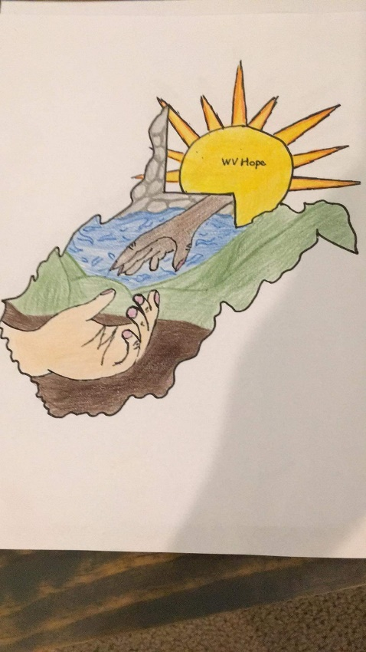WV Hope

(An Alternative to

White Cross)

***WV Hope is a new 2019 Ministry for WV American Baptist Women. White Cross Ministry is no longer a part of our National ABWM but instead is now a part of International Ministries WV Hope was created to allow ministry outreach to various charities and non-profit organizations within West Virginia. Now you can choose from the many White Cross projects (***[***www.internationalministries.org***](http://www.internationalministries.org) ***and scroll down the page until you see a brown box that says “Find a White Cross Project”) or one or all of the several WV Hope projects selected each year.***

***Each calendar year (commencing with 2021) there will be new ministries selected by the WV Hope Committee chaired by the First Vice-President of the State Executive Board. Recommendations will be accepted for consideration for the following year prior to April 15th each year. The number of ministry outreach programs will be determined by that Committee. Regardless of the number of programs selected, Weirton Christian Center will always remain as one of them.***

***For further information, please contact the First Vice-President for the current year whose contact information can be found on this website with the other current year officers.***